# 

# P1- Explain the personal attributes valued by employers

# [http://2.bp.blogspot.com/-pTPywSioUfI/TpKtKAIoGQI/AAAAAAAAAAw/G8p9Br2TkhA/s1600/leadership.jpg](http://www.google.co.uk/url?sa=i&rct=j&q=&esrc=s&frm=1&source=images&cd=&cad=rja&docid=Z0l3eQE2RllWXM&tbnid=SlEp2_3Rhv4ZpM:&ved=0CAUQjRw&url=http://listentojack.blogspot.com/&ei=ct2JUpUNpp7sBtDagegG&bvm=bv.56643336,d.ZGU&psig=AFQjCNG7poHTtH9uxH0Nqqj57Ze1OUIN6Q&ust=1384853221784911)

# http://en.blog.zyncro.com/wp-content/uploads/2011/05/computer-mediated-communication.jpg

**Introduction**

I am going to be discussing about how employers access and value each future employee. I am going to explain the following:

* **Specific job-related**: software hardware and security.
* **General**: planning and organisation skills, time management, team work, verbal and written communication skills and numeric skills and creativity.
* **Attitude**: Determination, Problem solving, Leadership skills and Independence

Every job has its own criteria to fill, and it will require to have various types of skills to able to do whatever you are doing. For example a teacher would need skills:

* Handle the class
* Deal with misbehaving children
* Teach so the students understand

If you could have another set of skills such as learning another language, it will give you an edge of other candidates. For example, if you are a teacher and a student doesn’t speak English, but speaks French. You could tell him in French of what’s going on.

**Specific Job-related:**

[](http://www.google.co.uk/url?sa=i&rct=j&q=&esrc=s&frm=1&source=images&cd=&cad=rja&docid=jRGWh2up_h2PIM&tbnid=YVpBj_E8EgPC6M:&ved=0CAUQjRw&url=http://www.lovetefl.com/online-tefl-courses/some-dos-and-donts-of-teaching-english-abroad/&ei=oOWAUtfAG7P40gW0pIHQBg&bvm=bv.56146854,d.ZG4&psig=AFQjCNHMKenSrh_SdaGd8O5XkRgZ9HirQg&ust=1384265498515430)**Technical Knowledge**

Having the correct knowledge for your job is very important to secure a successful place. This doesn’t just rely on the knowledge of the job. However, the skills that will make you a successful candidate. For example if I got a job interview as a Network Manager, but I never knew anything about it. The employee would think that I am not good enough candidate, because I wouldn’t know what to do. Network managers role involve to monitor the network, deal with problems or faults and more. Employers wouldn’t expect you to be technical, but some knowledge of the issues.

**Working procedures and systems**

[](http://www.google.co.uk/url?sa=i&source=images&cd=&cad=rja&docid=ujoCmrlQxu7GHM&tbnid=XBIrPeekOhurkM:&ved=0CAgQjRwwAA&url=http://www.solarsigns.co.uk/acatalog/Solar_Signs_Menu_Site_Safety_Signs_623.html&ei=C-qAUtH7HoHE7Abwi4CIAg&psig=AFQjCNHi0f5XAJQSRnmD55N1PSbyuHXf-Q&ust=1384266635554956)When working in a public environment, everybody needs to be aware of the risks and hazards that could occur when working with other people. If people leave chairs, there is a risk of someone tripping over and hurting themselves. Health and safety work act (1974) is a legislation to protect anybody in their working environment. This is to protect not only adults, but students and children. The act came about in 1974 and includes to take care of other people. For example in a school, the teachers make all the students put the chairs in whenever they leave the room. This could prevent someone breaking their arm. If someone has not got not good working conditions, it’s breaking the law. Having bad posture whilst working on the computer could cause long-term back-pain. Some could be muscle aches, repetitive strain injury, pain in the neck; shoulders; wrist or hand. To prevent these injuries from happening, sit up straight with an adjustable seat. Also, take regular breaks. Another risk could be that working with computers could damage your eyesight. Computer users should take regular eyesight test to monitor their sight.

**[](http://www.google.co.uk/url?sa=i&rct=j&q=&esrc=s&frm=1&source=images&cd=&cad=rja&docid=3YCYOuyDvVgVYM&tbnid=-SeqgpgXdHO-wM:&ved=0CAUQjRw&url=http://www.teach-ict.com/gcse_new/legal/dpa/miniweb/&ei=cG9NUt_OG-is7QaA5IHICA&bvm=bv.53537100,d.ZGU&psig=AFQjCNH7WfTRlEOHAMkDpTEvIxgDJZWRUA&ust=1380892906437598)Data Protection Act** was introduced in the 1998 for any organisation that deals with information, that transfer data needs to be fairly and lawfully processed. This law was set for every employee as this is vital that the employee’s vital information cannot be reach to anyone. Only certain information is taken, to ensure the safety of the employee is harmless. It is supposed to be secure so nobody can get hold of the information. Data has to be confirmed that the data is accurate. For example in LSC, certain employee’s information cannot be held with another functional area/employee. For example, if the human resources department have all the data for the employees and the finance department asks information about details about the employee. They will give the basics; name, how much they get. They can’t give anything else. If the data protection act is misused, they will either get fined, prosecuted. Others can get hold of this vital information and can do anything with it. They will get fined as they have not followed this legislation.

**[](http://www.google.co.uk/url?sa=i&rct=j&q=&esrc=s&frm=1&source=images&cd=&cad=rja&docid=WvxycETR_haTSM&tbnid=KdLTtbsP3iCeSM:&ved=0CAUQjRw&url=http://www.careers.manchester.ac.uk/students/employable/skills/organisation/&ei=pe6AUtnGO_OR0QW--4C4Aw&bvm=bv.56146854,d.ZG4&psig=AFQjCNF7Lxn3Dcy2bpzWwkiguC8TPdcFIw&ust=1384267808159600)General**

**Organisational skills** are important in any workplace. If you don’t plan and organise, you will fall behind. Employers value this skills as if you are not very organised, you will fall behind and have a heap of work to complete. Staying organised will help you complete work and know what you are doing whilst you are working. For example, if I am completing my work and I need a sheet with it to complete, but I don’t have it. It will delay the process and will not be complete.

**Time management** is very important as this means the process of planning and exercising conscious control over the amount of time a person spends on a specific activity. In a workplace, this is very important. Especially if you are a teacher, you only have 1 hour or more to teach a group of students. If you spend vast amount of time on one activity, you will not have time to complete the rest task that was planned. Employers will access other employees, sometimes, on how you deal with other people.

[](http://www.google.co.uk/url?sa=i&rct=j&q=&esrc=s&frm=1&source=images&cd=&cad=rja&docid=oGzv89CUsTQvPM&tbnid=iAYVL1lLxOsBiM:&ved=0CAUQjRw&url=http://laisogata.wordpress.com/&ei=lgiCUu3AL4XE7AaXu4HIBQ&bvm=bv.56146854,d.ZGU&psig=AFQjCNHvkQp-6NpNrUNj8gfiNmc-fKZZrA&ust=1384339982357962)**Teamwork** involves working with others. Once you have your first job, it’s very likely you will be working as a team. This is because you need to get used to the environment and how the procedures go at the working conditions. A team normally has a team leader who will monitor and give instructions for what to do. A team involves key skills to be successful such as:

* Understand your role and you’re expected to be successful at the role. Any instructions that you don’t understand, go to your team leader and he will clear it for you
* Deal any issues and negative peers positively
* If a team member is absent, take their role by being a successful team leader
* If any deadlines given, hand it in on time
* Don’t miss any days of work

**Attitudes**

[](http://www.google.co.uk/url?sa=i&source=images&cd=&cad=rja&docid=Lo9ZeFPxGRE8FM&tbnid=ohIGq1cLSFW65M:&ved=0CAgQjRwwAA&url=http://emilykaty.wordpress.com/&ei=8VmDUp2YAsnH7AbG5ICgBQ&psig=AFQjCNHFaBcfgiG-4CA7fdu9fOB4yUq-kA&ust=1384426353078222)**Attitudes** is valued by employees because its way the employee presents himself, it could be in terms of behaviour as well.

**Determination-** Work could be stressful and deal with a heavy lot of problems to solve. Employees are looking for people who don’t give up easily. They are looking for people who have the willpower to solve the problems under a lot of stress. People who lack determination and give up easily will not impress their employer. This is what employers look for the most, because if any employee gives up easily, to the employee, is not good enough. To summaries, this picture on the right, it shows that if you have determination you will keep fighting the obstacle and eventually beat that obstacle.

[](http://www.google.co.uk/url?sa=i&rct=j&q=&esrc=s&frm=1&source=images&cd=&cad=rja&docid=Hc6h7_wu90G2TM&tbnid=GqCg1k_cCDf8nM:&ved=0CAUQjRw&url=http://www.managershare.com/2013/04/02/top-10-soft-skills-for-job-hunters/&ei=_FqDUob5HY6rhQfts4DgAQ&bvm=bv.56343320,d.ZGU&psig=AFQjCNFriGvix724-m4JuePV-1RUjU90Tw&ust=1384426542421039)

**Problem solving** could be a heavy load for employees. In your first IT job, you would realise instantly that problems are always alerted. This is how the employee takes on the task. If it’s your first time trying to solve a problem, it would be heavy unlikely to solve it. However, it depends on how you big the issue is. If you can solve a problem, it would be impressive to the employee. Also, solving problems always deals with experience. If you have a lot of experience in problem solving, the better you are going to be good at it.

**Leadership skills** is when one person in a group of people takes charge and gives instructions. This needs to be clear on how they give instructions. For example, if a leader says to his teammates to complete their assignment by tomorrow but someone didn’t hear. The assignment wouldn’t be complete. Therefore, they need to give clear and concise instructions so that everybody understands and knows what you are talking about. If you are using difficult words towards 12 year olds. They wouldn’t understand. Also, tell everybody to do something. These points mentioned, employers look at the most. Employers look at this skill the most because if you get a task to complete which involves you being leader, you will need this skill being up-to-scratch.

[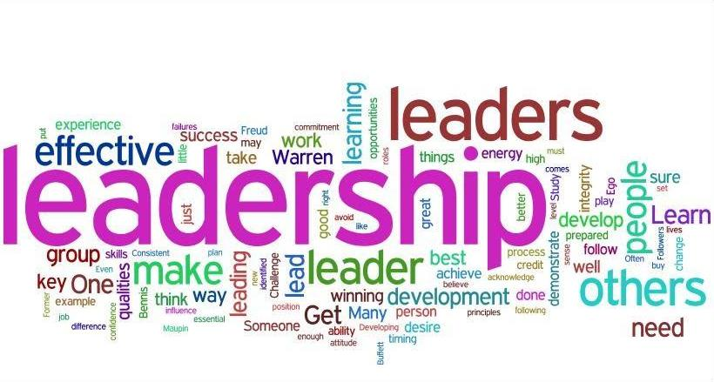](http://www.google.co.uk/url?sa=i&rct=j&q=&esrc=s&frm=1&source=images&cd=&cad=rja&docid=MkHIfEk3zRp_EM&tbnid=Q08VYcGCTdvbdM:&ved=0CAUQjRw&url=http://www.impactfactory.com/tailored_leadership.html&ei=vn2DUs_kCoLT7Aae34DQDw&bvm=bv.56343320,d.ZGU&psig=AFQjCNHkw4otUVPwwwGTxWgsE_HE7Krj3w&ust=1384435293828611)

**Independence** is working alone. Everybody needs to work alone at a point, because if you are keep on getting support by someone, you cannot complete it once the person is not there to support you. An employer wants every employee to be independent. There is no point of having an employee if he keeps asking for help. The employers want their employees to make own decisions and not ask for others help. Of course, when we are really stuck we can ask for help. However, not repeatedly.

[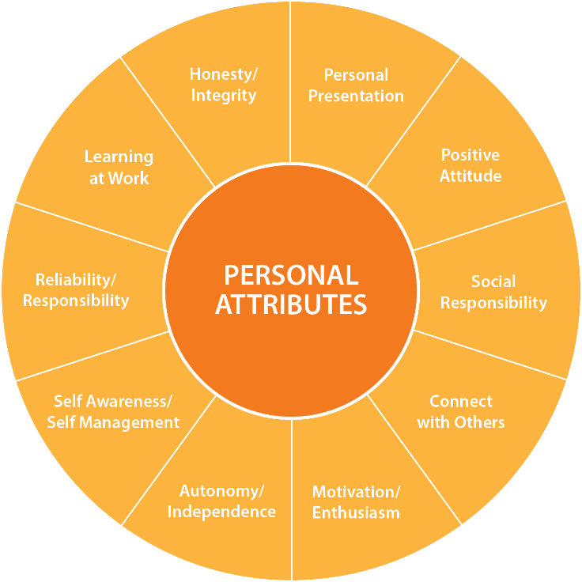](http://www.google.co.uk/url?sa=i&rct=j&q=&esrc=s&frm=1&source=images&cd=&cad=rja&docid=O8QL4Fnx2Dyw6M&tbnid=mzLaaIs76q8hzM:&ved=0CAUQjRw&url=http://www.bliip.co/bliip-personal-attributes/&ei=steEUo7EIKmI7Aa5vYDQAw&bvm=bv.56343320,d.ZGU&psig=AFQjCNG0ZkfPTf0NLhqu_CwrSPC5gnS3Dw&ust=1384524070590020)*It’s not all about having the most qualifications, but showing the employee how it’s done. For example if I was to have a degree in computing, but I don’t have the general attributes to succeed. The employer will not employ you. They want people to be in both, educational and personal attributes, to be successful in an interview. However not just having them will make you successful, you will need to show them off at the interview.*